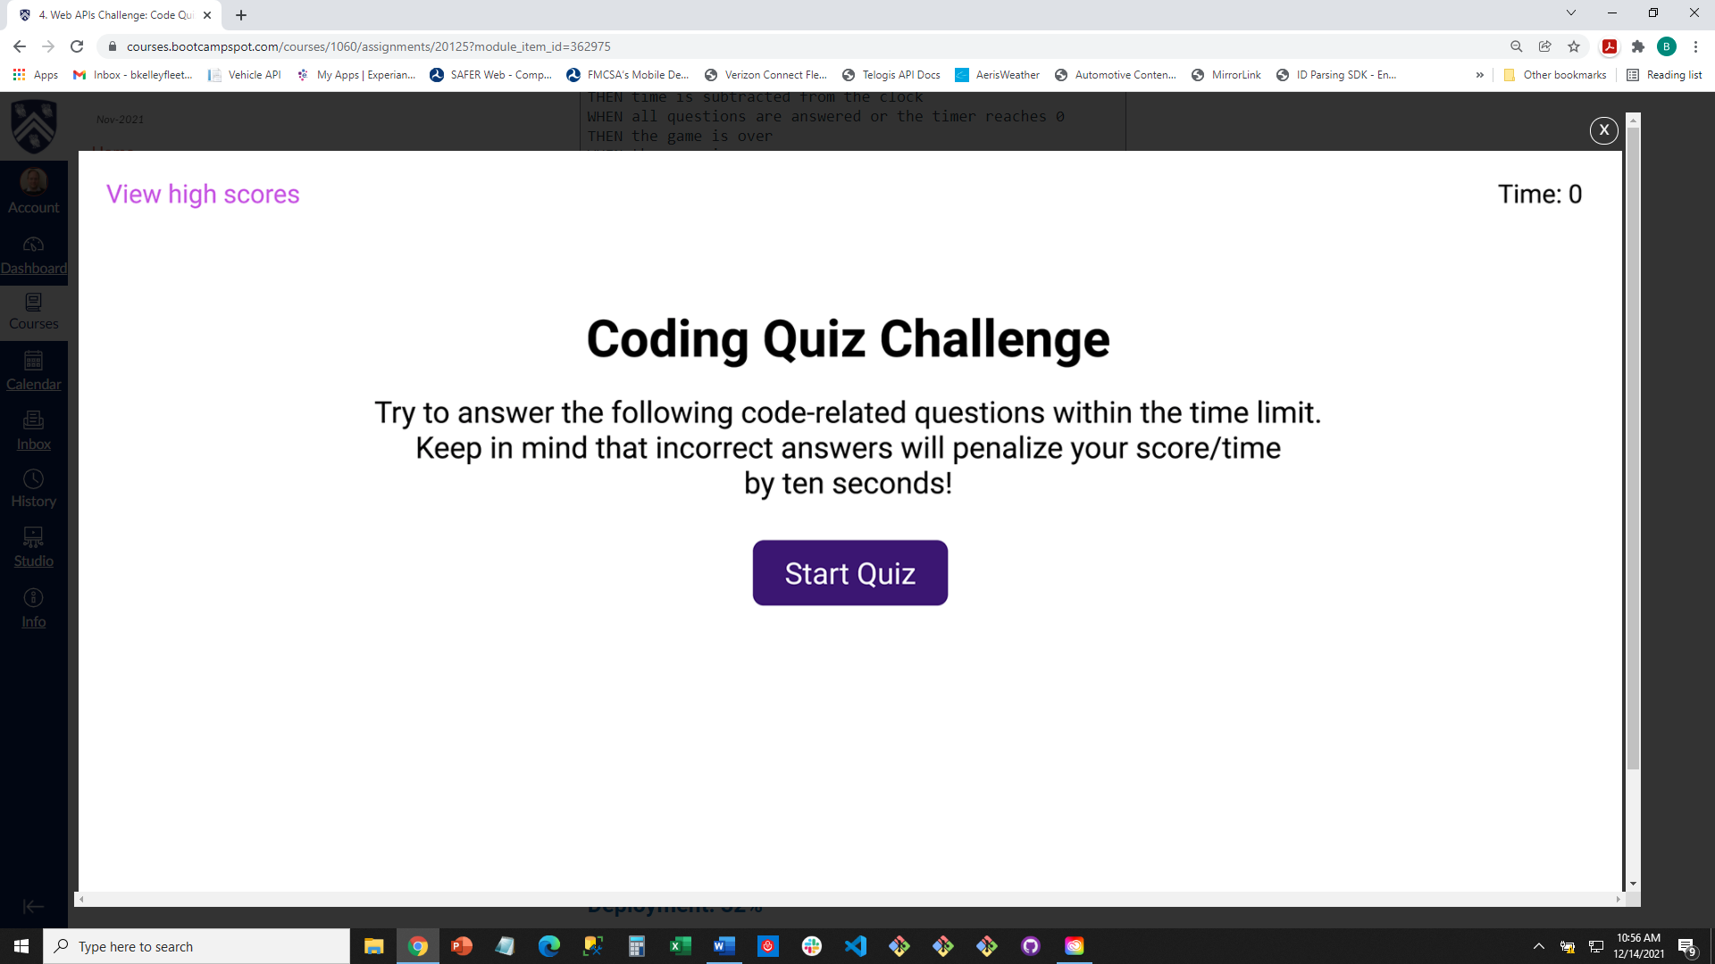

Coding Quiz Challenge

Try to answer the following code-related questions within the time limit. Keep in mind that incorrect answers will penalize your score / time by ten seconds!

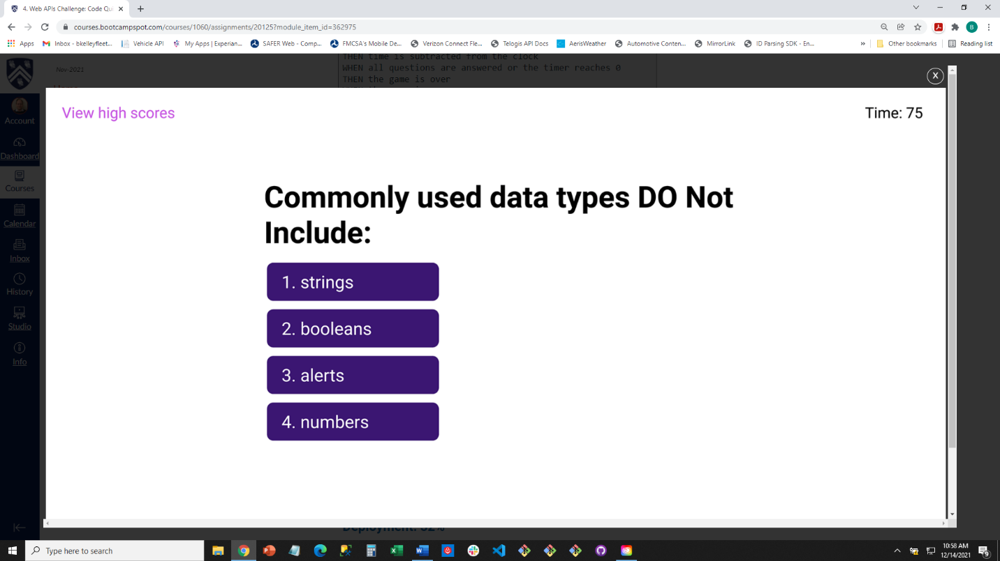

Commonly used data types do not include:

1. strings
2. booleans
3. alerts
4. numbers

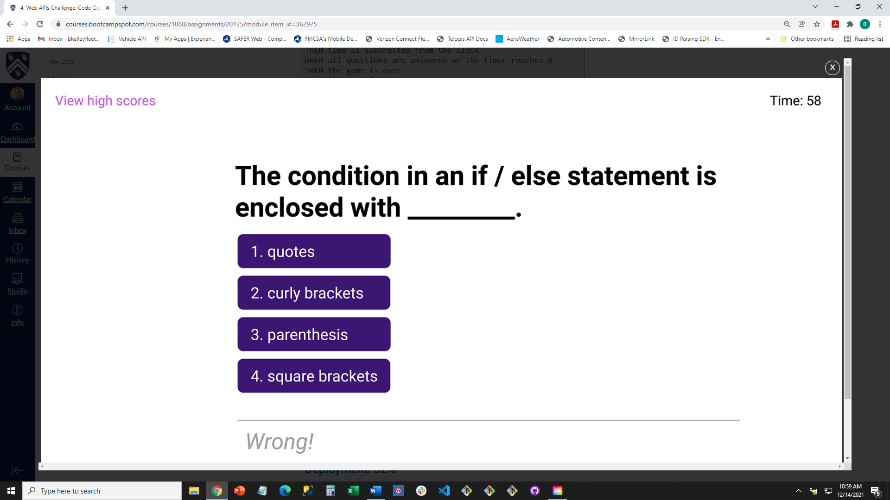

The condition in an if / else statement is enclosed with _____________.

1. quotes
2. curly brackets
3. parenthesis
4. square brackets

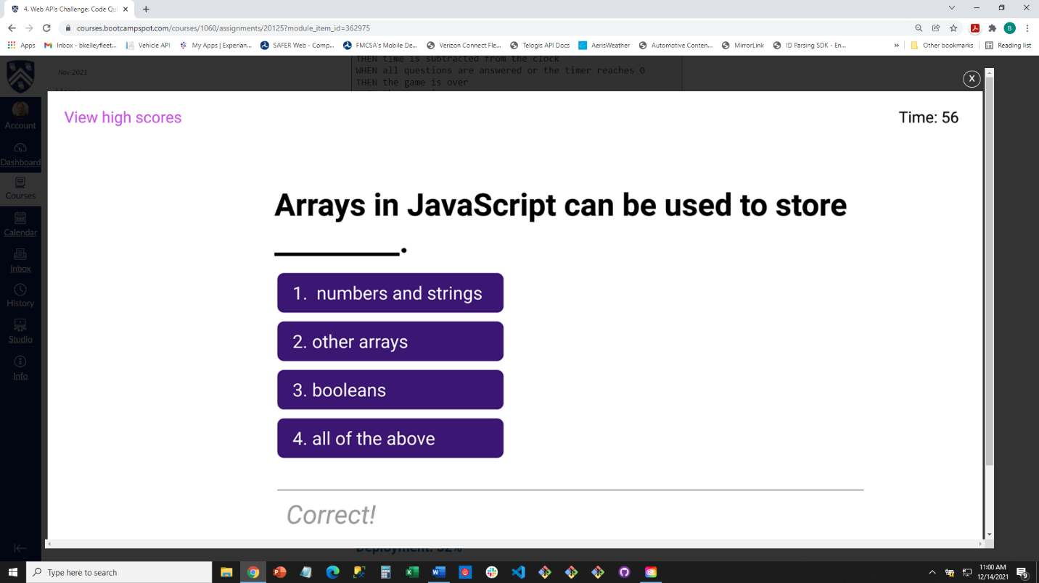

Arrays in Javascript can be used to store ________________.

1. numbers and strings
2. other arrays
3. booleans
4. all of the above

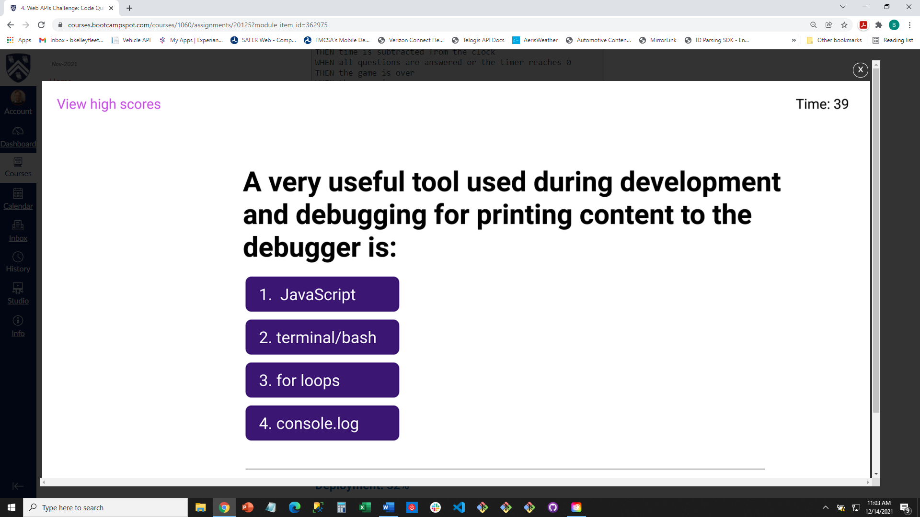

A very useful tool used during development and debugging for printing content to the debugger is:

1. javascript
2. terminal / bash
3. for loops
4. console.log

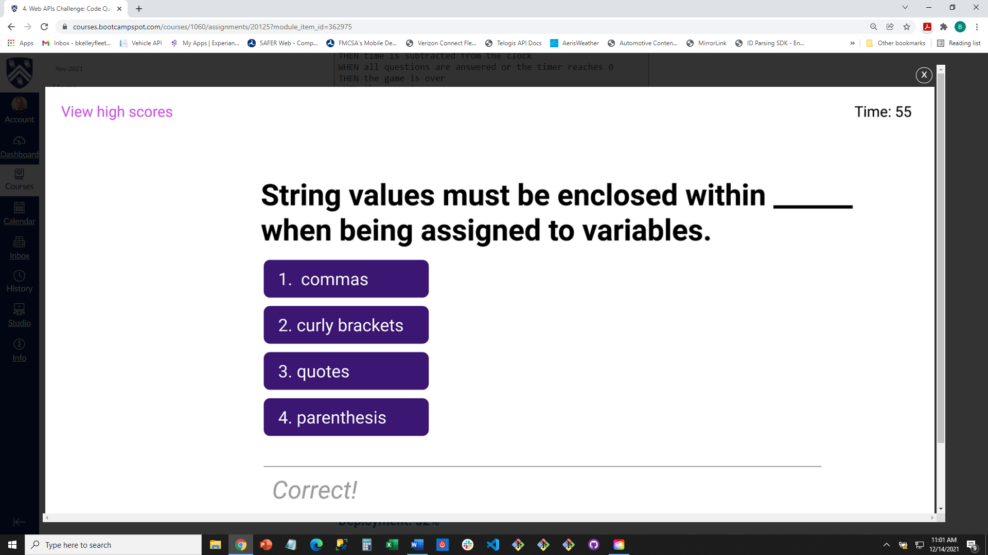

String values must be enclosed within ___________ when being assigned to variables.

1. commas
2. curly brackets
3. quotes
4. parenthesis

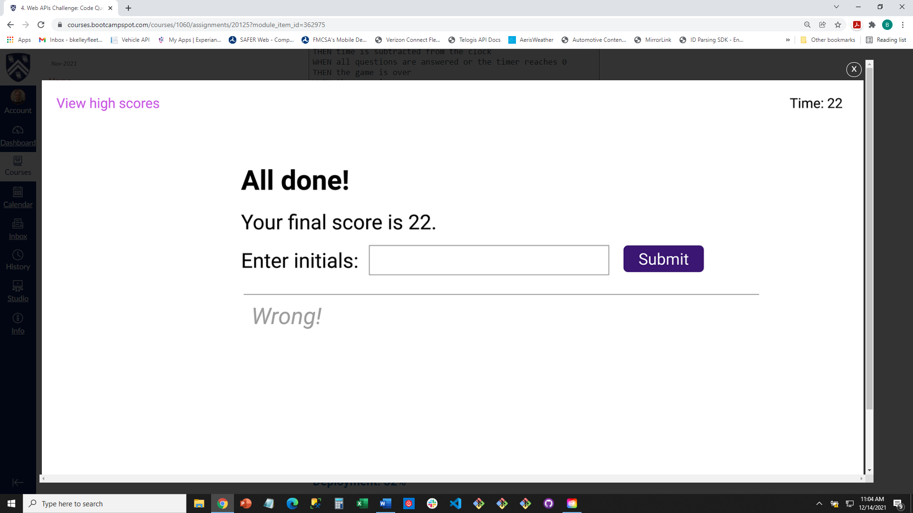

All done!

Your final score is

